Create multiple instances with different names.
1. Connect ec2 server
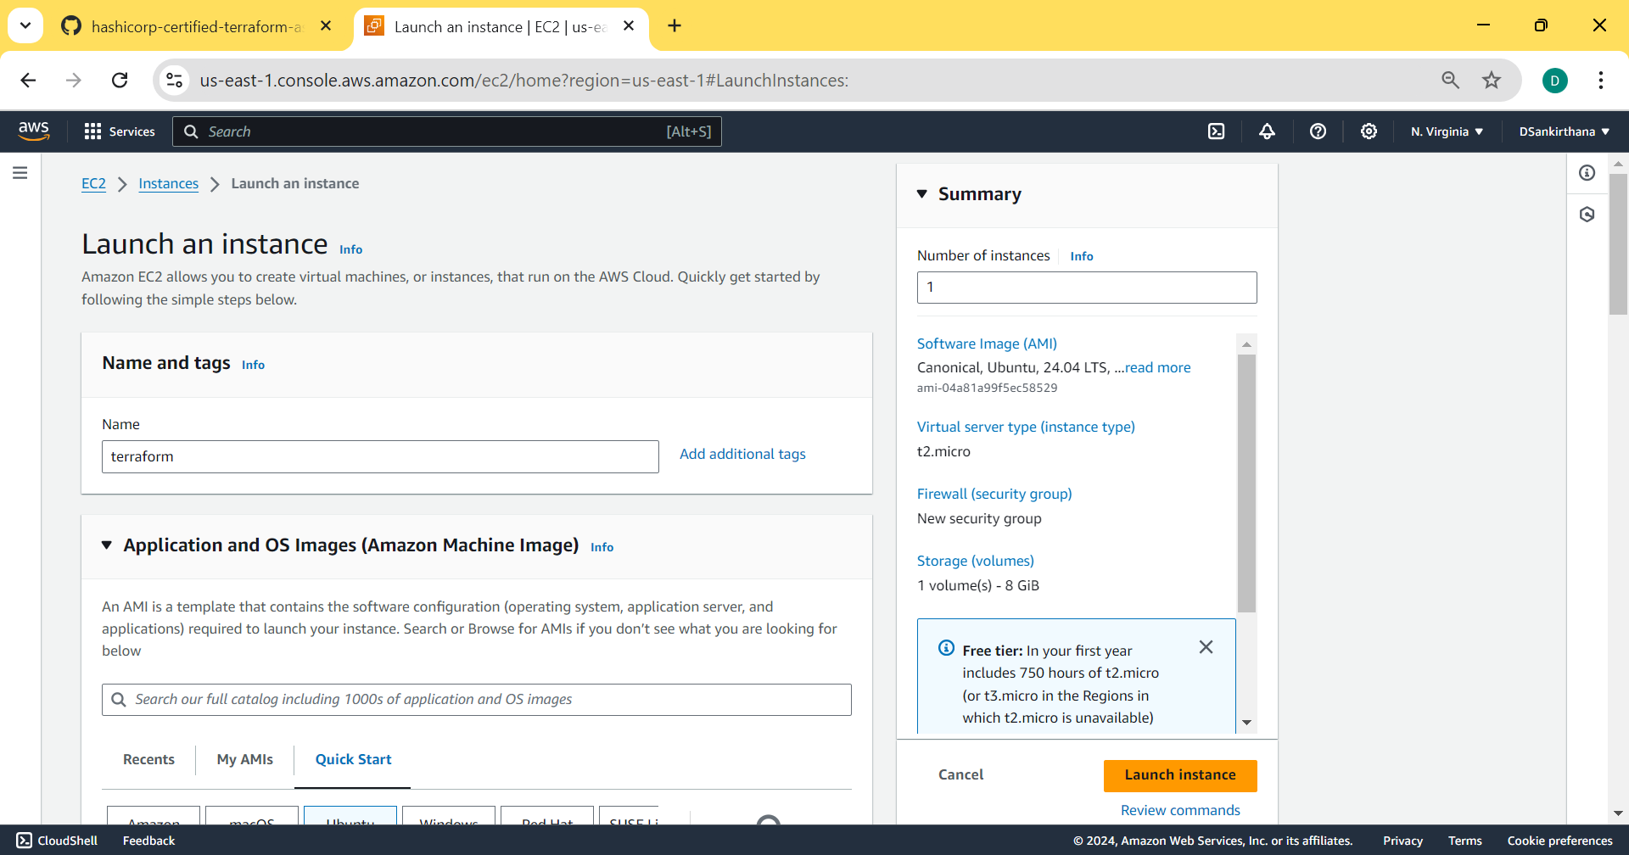
2. Install the following and connect
- Aws cli
- Terraform download
- Terraform provider
3. Create IAM user -> Get Access Key Id and Secret Access Key and go with AWS Configure. AWS Configure is used to get our user login credentials to the provider block which is used to connect to the EC2 server.
4. Create a directory using the command mkdir terraform
5. Edit the blocks and connect them to the server.
- Terraform block
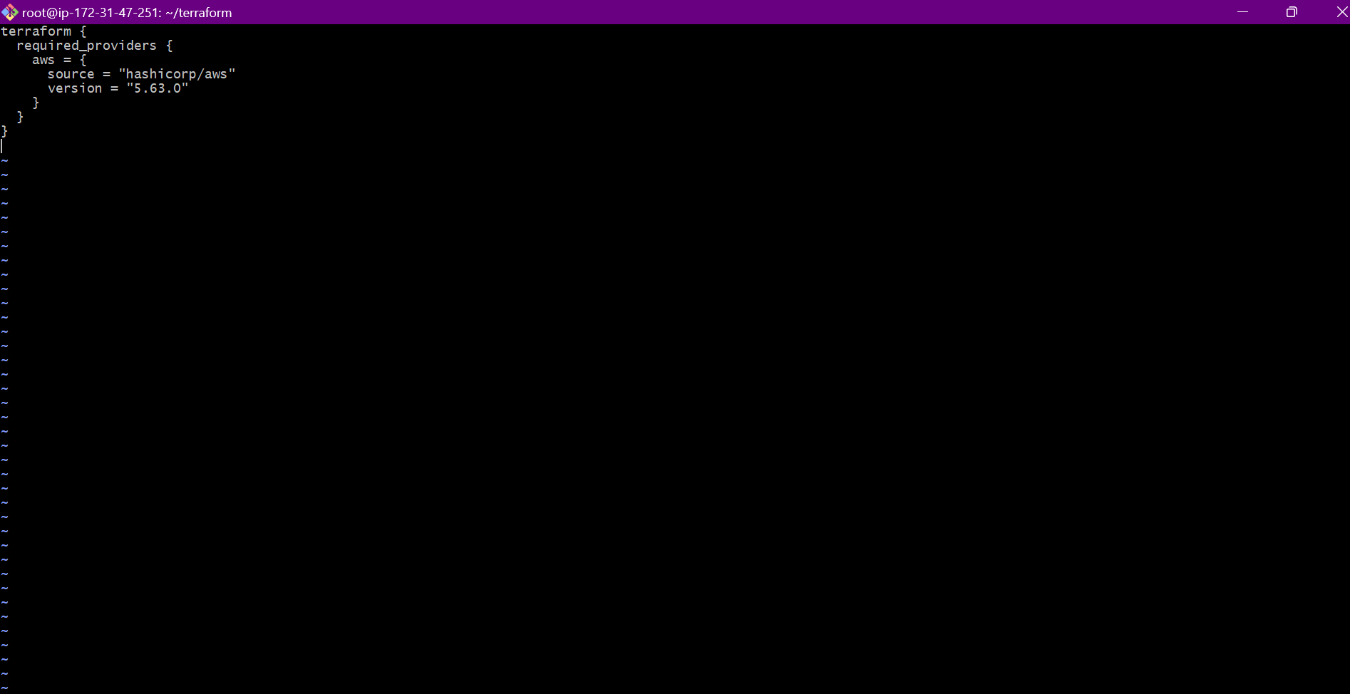
- Provider block
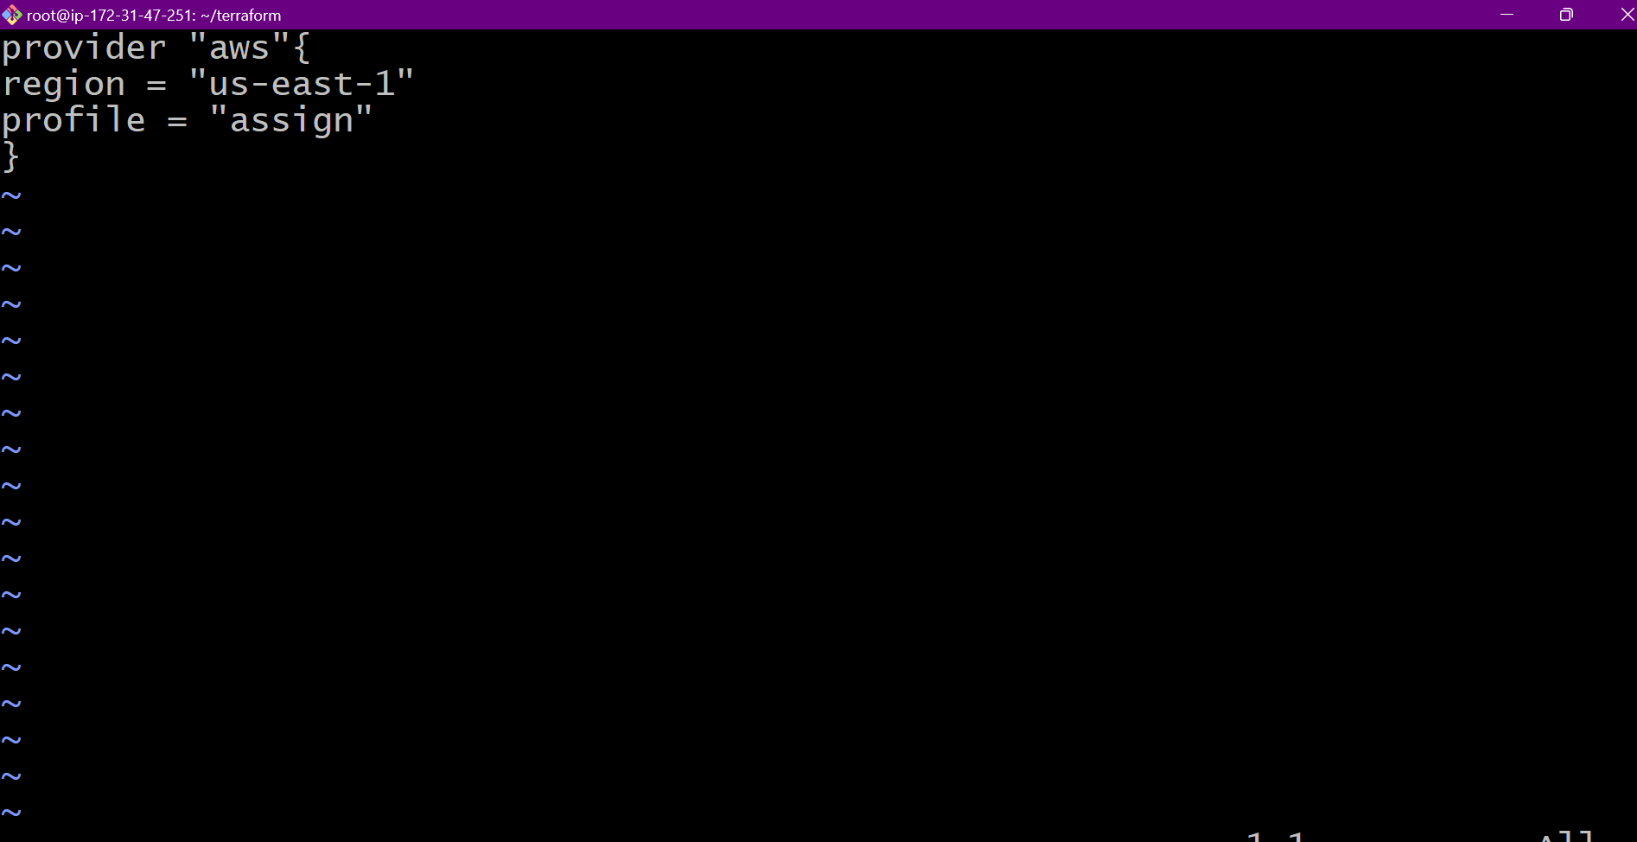
- Resource block
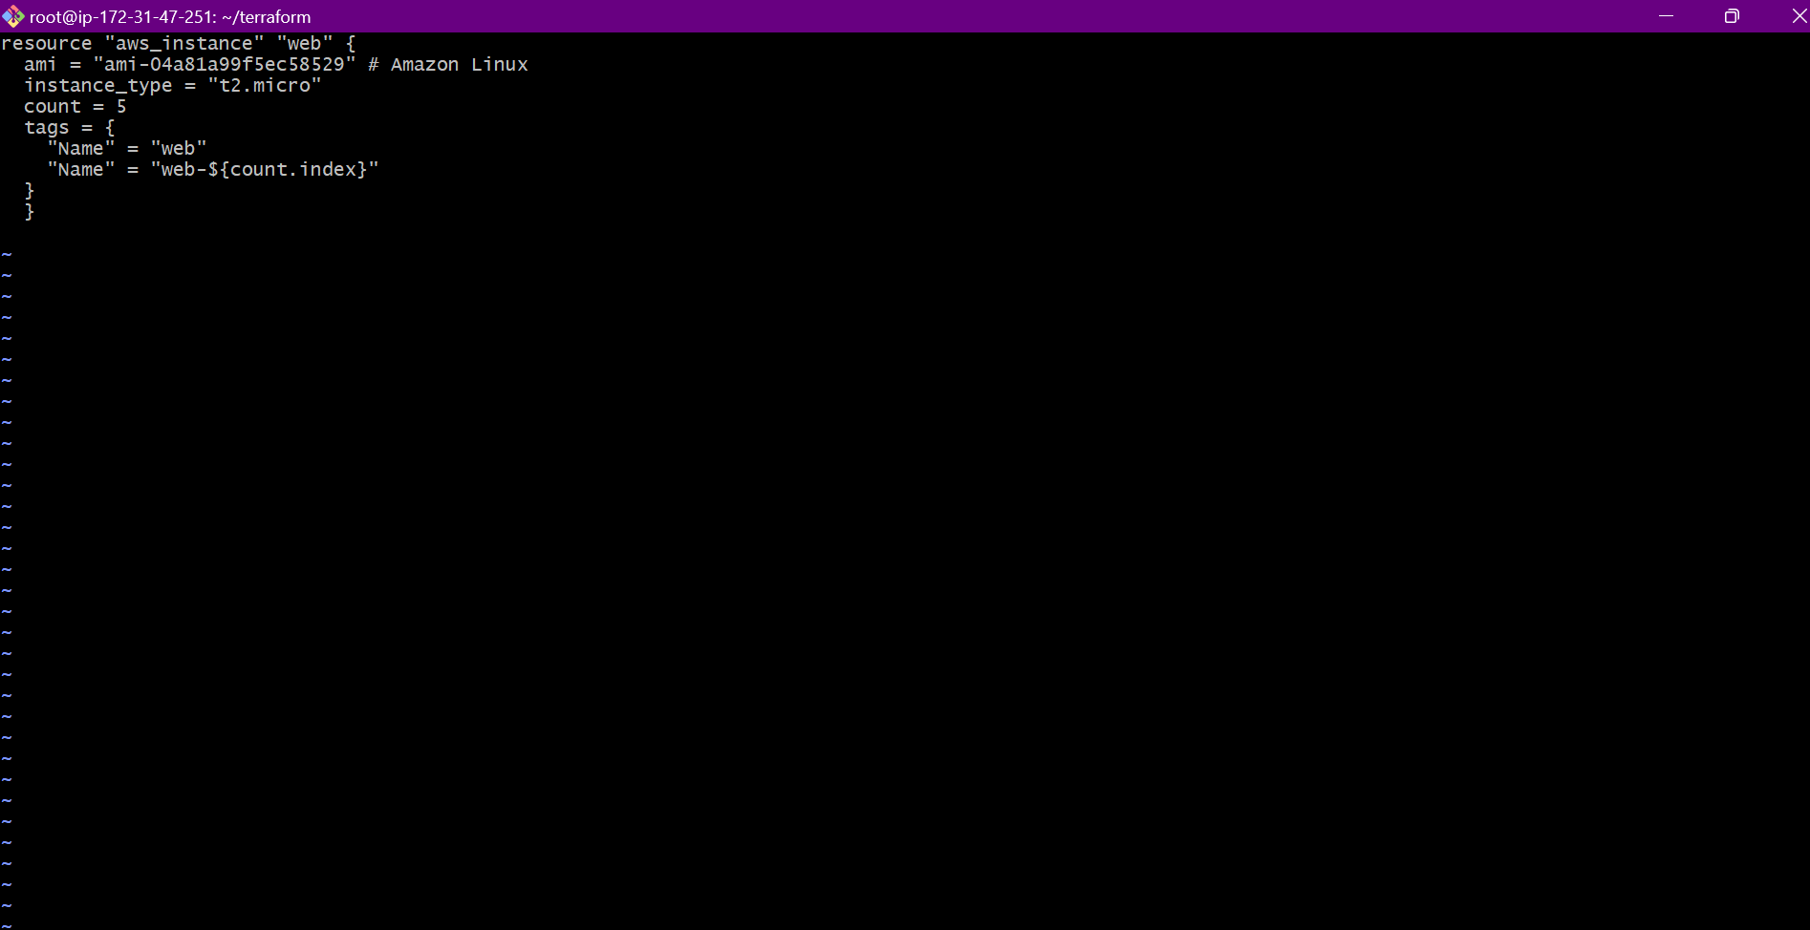
6. Terraform Workflow
It contains
- Init
- Validate
- Plan
- Apply
- Destroy
Run first 4 commands to get the output
